Public Health Information eXchange (PHIX)

PHIX Operations Guide
Version 1.3.1.0

February 2, 2012

VERSION HISTORY

Version # | Implemented By | Revision Date | Approved By | Approval Date | Reason
1.3.1.0 | Paul DeJong | 02-Feb-2012 |  |  | Initial version of document, coinciding with PHIX 1.3.1.0 release.

TABLE OF CONTENTS

1. Introduction 4
1.1 Objective 4
2. PHIX component Startup order 5
2.1 PostgreSQL 5
2.2 JBoss / MSS / PHIX Services 5
2.3 Mirth Connect 5
2.4 hMailServer 5
2.5 Linker/Anonymizer 5
2.6 NHIN Direct REST 5
3. MIRTH CONNECT 6
3.1 Mirth Connect Administrator 6
3.2 Mirth Connect Logfile 6
4. PHIX Log files 7
4.1 PHIX Event Log 7
4.2 PHIX Error Log 7
5. PHIX RECONFIGURATION 8
5.1 Organizations 8
5.2 Routing 9
5.3 Conformance Profiles 10
5.4 Email Recipients 11

Introduction

1.1 Objective
This document aims to instruct Public Health Information eXchange (PHIX) administrators and system operations staff with the knowledge needed to run and reconfigure a typical PHIX installation. Listed below is a diagram of the PHIX portal application, which is a community access web site designed to provide access to the PHIX solution for public health organizations and health care providers and to further expand the capabilities of the PHIX. This web site should also be consulted for further information and documentation concerning PHIX. The Portal URL is http://phix.phiresearchlab.org .

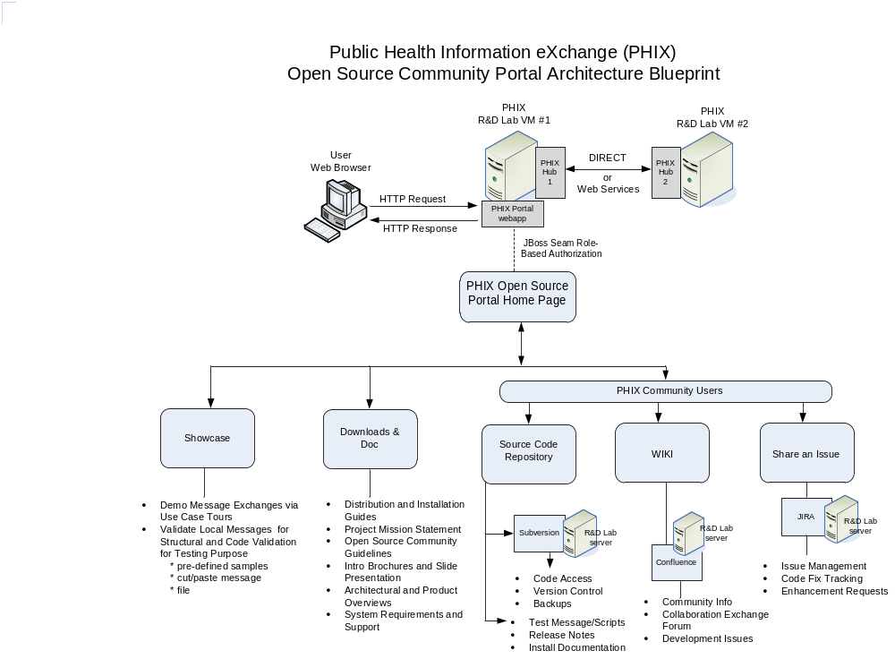

PHIX component Startup order
This section describes the order in which the various PHIX components should be started when preparing to use PHIX. Depending on your configuration, not all components may be present on your system, components may be installed in a different location than specified, or components may be set to start automatically when Windows starts up.

2.1 PostgreSQL
The PostgreSQL database should be installed as a service. If it is not set to AUTOMATIC start, it can be started by highlighting the “postgresql-9.0 – PostgreSQL Server 9.0” service and selecting “Start” from inside the Windows Services Manager.

2.2 JBoss / MSS / PHIX Services
JBoss should be started next. If it is installed as a service, it will likely be named “PHIX 1.3” under the services manager.

In the event that you are using MSS components and need to start JBoss manually, JBoss is likely located under C:\mss35\MSS\jboss\bin\ Execute .\run.bat from this directory.

If you are using JBoss without MSS, and need to start JBoss manually, locate the bin\ directory under your JBoss installation, and execute .\run.bat from this directory.

2.3 Mirth Connect
Mirth Connect should be installed as a service and named “Mirth Connect Service” or similar. If it is not set to start automatically, start this service from the Windows Service Manager.

2.4 hMailServer
If you are using the hMailServer component as our SMTP server, start this service next. It is comprised of “hMailServer” and “hMailServerMySQL” under the Windows Service Manager.

2.5 Linker/Anonymizer
If you are using the Linker/Anonymizer component and it is installed as a service, it should be named “PHIX Linker Anonymizer”. Start it now if it is not set to start automatically.

2.6 NHIN Direct REST
If you are using NHIN Direct REST for message transport, start it now. If you have it installed as a service, it will be called “PHIXDirect”. To start it manually, change to the c:\nhin-d-rest\sprint-maven-poc\ directory, and execute “mvn jetty:run”.

3. MIRTH CONNECT

3.1 Mirth Connect Administrator

The primary area used for monitoring processing HL7 messages is the Mirth Connect Dashboard. This area can be accessed from the Mirth Adminstrator under either the Mirth Connect program group, or the Mirth icon in the system tray.

Once the Mirth Administrator is started, select the Dashboard option on the top left. This view will show you the number of messages received, processed, sent, and errored out by the channel. The channel named “01_PHIX” performs most of the processing.

To get more detailed information, double-click on one of the deployed channel. This view shows the status from calling each connector for all messages, starting with the most recent message processed. You can move back through the message using the navigation arrows on the top-right. Statuses will include SENT, FILTERED, or ERROR. FILTERED connections mean the connection was bypassed due to configuration (for example, because the type of message being processed is not configured to perform code validation). SENT means the connection was successfully executed. ERROR means something preventing the message from being processed by the connection. If you select one of the connections, you will have a variety of options for viewing the message, variables, and errors by clicking the tabs at the bottom of the console.

3.2 Mirth Connect Logfile

Mirth Connect also maintains a log that repeats much of the data you see on the dashboard. It is located in C:\MirthConnect2\logs\mirth.log, or similar depending on where Mirth is installed on your system.

4. PHIX Log files

The PHIX system maintains its own execution logs for processed messages, and another log detailing errors.

4.1 PHIX Event Log

On a standard PHIX installation, the PHIX log for processed messages will be located in C:\phixdata\logs\phix_events.log. This log details the message version, type, trigger event, filename, PHIX configuration information, custom processing information based on the type of message, which PHIX services were executed for the message, and any errors that may have occurred. Every message processed by PHIX will create a single entry in the event log. Batches of messages are processed as individual messages by PHIX and will therefore appear in the event log as a sequence of single messages.

4.2 PHIX Error Log

An additional log file contains PHIX errors encountered while processing messages. By default this file will be located in C:\phixdata\logs\phix_events.log. This format contains much of the same identifying message information as the event log file, plus a detailed list of errors that were encountered. If no errors were encountered during the processing of a given message, no entry will be made in the error log.

5. PHIX RECONFIGURATION
The PHIX system comes configured with support for only a limited number of messages and conformance profiles. This section details potential situations you may encounter that require configuration of your PHIX installation based on changing business needs. Note: If you change any configuration items, refresh and redeploy your mirth channel and restart JBoss as appropriate to ensure that the changes take affect.

5.1 Organizations

Organizations represent the entities that either send or receive HL7 messages. They may or may not be PHIX installations. Organizations are represented by a single row in the “organization” table within the PostgreSQL “hub” database.

The following is a description of the database columns:

COLUMN NAME | DESCRIPTION
id | Primary key, should come from nextval(‘organization_seq’)
name | Descriptive name of Organization
facility | Must match sending or receiving “facility ID” from MSH-4.1 or MSH-6.1
direct_email | Organization address only when equipped for sending/receiving messages with NHIN Direct REST
notification_email | Email address where Notifiable Condition alerts are sent when configured with MSS Subscription service
ws_host | Web Service endpoint for Organizations that are equipped to send/receive messages over web services (SOAP)
xport_type | The type of transport the Organization is equipped to receive messages by. One of: DIRECT (NHIN Direct REST), MIRTH_WS (Mirth native web services). Some PHIX installations may support additional types if so configured.
hub_host | The fully qualified domain name for the organization or system. For Organizations that are PHIX installations, this value corresponds to the “hubHost” variable set in the 01_PHIX source transformer.
error_email | The email address that is configured to receive notification of failed messages sent by this organization

If you plan to start receiving HL7 messages from an additional source, you will likely create an organization entry for the partner, as well as a component_routing rule for each message type you plan to receive (see below).

5.2 Routing

The component_routing specifies which PHIX components are utilized based on message type, sending facility, and receiving facility; as well as where the message should be sent once processing is complete, if anywhere. It also has the capability to specify a custom profile to be utilized for this specific routing in case that the default profile for this message type should not be used.

The following table describes the columns inside the component_routing table. A unique component_routing entry is defined by the composite key msg_type, trigger_event, hl7_version, sending_facility_id, receiving_facility_id.

COLUMN NAME | DESCRIPTION
id | Primary key, should come from nextval(‘component_routing_seq’)
msg_type | The type of HL7 message; from MSH-9.1
trigger_event | HL7 trigger event for this message type; from MSH-9.2
hl7_version | The HL7 version of the message; from MSH-12
sending_facility_id | Foreign key pointing to the organization table row representing the message sender, whose facility column matches the value in MSH-4.1
receiving_facility_id | Foreign key pointing to the organization table row representing the message receiver, whose facility column matches the value in MSH-6.1
structural_validation | ‘t’ if the PHIX StructuralValidationService should be invoked, ‘f’ otherwise. If ‘t’, a profile must exist for this msg_type, trigger_event, and hl7_version in the conformance_profile table
vocab_translation | ‘t’ if the MSS VocabTranslation service should be invoked, ‘f’ otherwise. If ‘t’, vocab translation rules must be configured using the MSS Portal.
code_validation | ‘t’ if the MSS CodeValidation service should be invoked, ‘f’ otherwise. If ‘t’, code validation rules must be configured using the MSS Portal.
subscription | ‘t’ if the MSS Subscription service for notifiable conditions should be invoked, ‘f’ otherwise. If ‘t’, subscription rules for notifiable conditions must be configured using the MSS Portal.
anonymization | ‘t’ if the Linker/Anonymizer service should be called to anonymize PII data within the message, ‘f’ otherwise.
add_sft_segment | ‘t’ if an additional SFT (software) segment should be appended to the message specifying that is was processed by PHIX, otherwise ‘f’.
add_spm_segment | ‘t’ if an SPM segment should be added to the message
translate_to_version | If this message should be translated to another HL7 version, it is specified here. Support for this type of translation will then need to be added to PHIX. Currently, only a limited translation of ORU 2.3.1 to 2.5.1 is supported by PHIX in order to demonstrate this functionality.
vocab_translation_mss_profile | The name of the MSS profile used to configure the MSS VocabTranslation service. Required only if vocab_translation is set to ‘t’.
code_validation_mss_profile | The name of the MSS profile used to configure the MSS CodeValidation service. Required only if code_validation is set to ‘t’.
structural_validation_regexp_filters | Optionally used to filter out specific errors from being returned by the StructuralValidationService. Must be in regular expression format. Multiple filters are delimited by |.
custom_profile_name | Optionally identifies a custom profile to be used with this component routing entry, rather than the default profile for this msg-event-version combination. If present, must match a component_routing.custom_profile_name field.

If you need to support additional message types or versions, you will create a component_routing entry for each sender-receiver combination that will exchange the message, plus insert the appropriate conformance_profile for the message type (see below).

5.3 Conformance Profiles

Conformance profiles are used with structural validation. They are first created with HL7 Messaging Workbench or a similar product, and then inserted into the database. For each msg-trigger-version combination PHIX will process, a conformance profile must be loaded into fix in order to perform structural validation.

The following table describes the columns inside the conformance_profile table. A unique conformance_profile entry is defined by the composite key msg_type, trigger_event, hl7_version.

COLUMN NAME | DESCRIPTION
id | Primary Key, should come from nextval(‘component_routing_seq’)
msg_type | The type of HL7 message; from MSH-9.1
trigger_event | HL7 trigger event for this message type; from MSH-9.2
hl7_version | The HL7 version of the message; from MSH-12
profile | The complete HL7 Conformance Profile, an XML document inserted as a string. When inserting, you may need to replace single quotes ' with two consecutive single quotes ' ' in order to insert the profile into this column.
custom_profile_name | Optionally identifies a custom profile to be used with one or more specific component routing entries, rather than the default profile as specified by a msg-event-version combination. This value must be unique within this table if it is specified.
description | An optional textual description of this profile entry.

A single key msg_type, trigger_event, hl7_version in an incoming message will be used to specify the default conformance_profile entry that will be used to structurally validate the message. However, in cases where a custom profile is desired for a certain message sender, and a conformance_profile entry already exists for this msg-trigger-version combination, a custom_profile_name can be used. A custom_profile_name is specified in both the conformance_profile row as well as inside the component_routing row that specifies the sending and receiver of the message that the custom profile will apply to. This causes the custom profile to be loaded and used for validation rather than the default profile for the message type.

5.4 Email Recipients

Email recipients for detected notifiable conditions and errors encountered while processing are sent to the email addresses specified in the organization table. By default, this only allows a single address to receive notifiable condition alerts and error reports. To change these addresses, update the appropriate entries in the organization table.

If you wish to configure additional recipients for either of these two email types, you can do so by cloning the appropriate destination in the 01_PHIX channel, and configuring a new address for the cloned destination. For example, if you wish error reports to be sent to an additional address, open the Mirth Connect administrator, select the Channels options, double-click on 01_PHIX, select the Destinations table, scroll down until you find “Email errors”, right-click on this destination, select “Clone destination”. Rename the newly created destination to something appropriate, and move it up in the destination list so that it occurs immediately after the original “Email errors” destination. Edit the new destination, replacing the contents of the “To:” field with the hard-coded email address you wish to receive email alerts.

The process is the same for additional notifiable conditional email alerts, except that the destination to clone is called “Send email alert for detected notifiable condition”.

